Year 7 Spring Term
History
History is full of stories…  Here are some of the big Medieval ones  1. 1135-53: The Anarchy.  Henry I promised the throne to his daughter, Matilda, after his son died. Would this be the first time England had a female king? When Henry I died, Matilda’s cousin Stephen took the throne resulting in a brutal civil war that plunged England into anarchy.  2. 1170: The Murder in the Cathedral.  Thomas Becket was the Archbishop of Canterbury during the reign of Henry II. Becket was murdered by some of Henry II’s knights…at the altar of his own cathedral! It was a shocking moment in medieval history.  3. 1215: King John and Magna Carta  King John fell out with his barons (rich noblemen who expected to be involved in running the country) They forced him to sign the ‘Great Charter’ (Magna Carta) to share some of his power with them. But has King John been unfairly blamed for what went wrong in his reign? Have historians treated him unfairly?  4. 1348: The Black Death  The ‘most terrible of all terrors’. The Bubonic Plague swept across Europe, carried by fleas living on the black rats on trade ships from China. Nearly half of the population of Europe died! No one at the time understood why. What did they do?! They prayed to God to show they were sorry for their sins, tried various ‘remedies’, none of which worked, and locked infected people in their homes. What else?  5. 1381: The Peasants Revolt  After the terrors of the Black Death, then years of wages being controlled, and having no rights, the peasants took their grievances to King Richard II (who was only 14!) in a huge rebellion which swept across England. | 6. The Crusades, from 1095  The big, religious ‘clash’ of the Middle Ages. Knights from England, France and Germany walked thousands of miles to the ‘Holy Land’ (Jerusalem) to fight Muslim warriors to get control of the Holy Places…and to take over land and steal riches!  7.  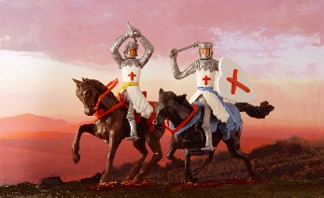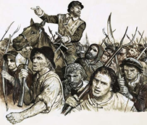  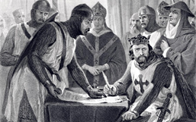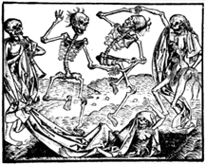  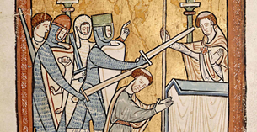  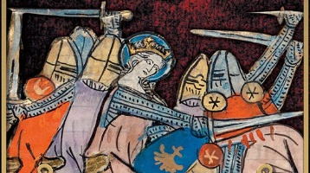  Which picture illustrates which of the 6 stories? | 8.  We usually say Medieval times (or the Middle Ages) date from 1000-1500 AD  If we want to be more specific, we can say that it starts and ends with two battles, the Battle of Hastings in 1066 and the Battle of Bosworth in 1485. A King died at both these battles: Harold Godwinson in 1066, and when King Richard III is killed in 1485, the TUDOR royal family comes to the throne. There are 5 (or 6!) Tudor monarchs:  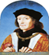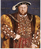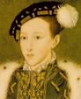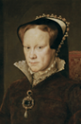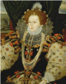  1.Henry VII (7th) 1485-1509  2.Henry VIII (8th) 1509-1547  3.Edward VI (6th) 1547-1553  4.(Lady Jane Grey…for only 9 days!)  5.Mary I 1553-1558  6.Elizabeth I 1558-1603  When Elizabeth - the last Tudor monarch - dies her cousin, King James VI of Scotland becomes king of England as well…but he is the first King James we have had, so WE call him King James I  His reign marks the beginning of the…  STUARTS

