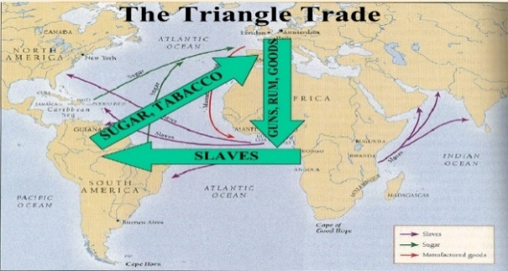  1)Trans-Atlantic Slave Trade: 10 million Africans transported to the Americas.  Tudor period 20,000 free Black people lived in England  1530s English traders started to go to West Africa where Portuguese merchants had been trading.  1562 John Hawkins led a voyage to capture and enslave African people. Britain’s involvement in the Trans-Atlantic Slave Trade began.  1627 English settlers started to farm sugar for profit in Barbados. Demand grew so they enslaved Africans to work on the sugar plantations.  Middle Passage The Journey from Africa to the Americas  Plantation A huge farm growing one type of crop  1807 Trading of enslaved Africans banned  1833 Enslaved Africans freed across the British Empire  2) Industrial Revolution 1750-1900  (A time of great change for Britain)  Enlightenment: natural thinking taking a lead over religious thinking  Agricultural Revolution: a complete change in farming methods  Scientific Revolution; a complete change in scientific thought  Cottage Industry: manufacturing done on a small scale in people’s homes  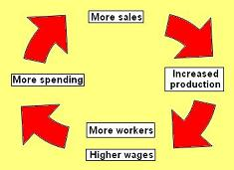  Industrial Revolution: a complete change from farming and domestic manufacturing to use of factories  Factors that caused the Industrial Revolution and led to the cycle of prosperity  Coal Enclosures  Increasing population Great individuals  Profits and products from slave trade | 3) Let’s recap the key people from Year 7  Martin Luther: put his 95 theses on the door of his Church in Wittenburg (started the Protestant Religion) in 1517  Royal Africa Company: set up in 1672, controlled trade on West coast of Africa, set up slave forts and British involvement in slave trade grew  William Wilberforce: leading abolitionist.  Mary Prince: published her book of experiences in 1831  Olaudah Equiano: bought his freedom and wrote a narrative of his life as an enslaved African in 1789  Toussaint L’Ouverture: led a successful revolt of enslaved Africans and emancipated enslaved Africans in Haiti  Nanny of the Maroons: organised successful plans to free over 1000 enslaved Africans in Jamaica and led a community of formerly enslaved Africans called the Windward Maroons.  4) Industrial Revolution  Jethro Tull: Invented the seed drill (1700)  Richard Arkwright: Invented the water frame (1769)  Robert Boyle: first modern chemist  John Heathcoat: English inventor from Derbyshire, invented a machine that made lace, moved his successful business to Tiverton.  Ada Lovelace: first computer programmer and brilliant mathematician  Timeline of Public Health________________________  1831: Cholera strikes  1842: Chadwick Report  1848: First Public Health Act  1854: John Snow proves cholera is in water  1858: Great Stink. Bazalgette is given money to build sewers in London  1875: Second Public Health Act  1889: Booth writes report on living conditions in London  1901: Rowntree writes his report on living conditions in York

