2) Key Terms  Triple Alliance: The agreement between Austria-Hungary, Germany and Italy  Triple Ententes: The agreement between Britain, Russia and France  Martyr: Someone prepared to die for their beliefs  Long-Term Causes: Factors that create the context of the time  Trigger Cause: A short-term factor that causes an event  Schleiffen Plan: Germany’s plan to defeat France quickly  August 5th 1914  First shot fired in Africa by Alhaji Grunshi  Oct-Nov 1914  First Battle of Ypres  July- Nov 1916. Battle of the Somme  August 4th 1914  Britain declares war  28th June 1914  Assassination of Franz Ferdinand and wife Sophie  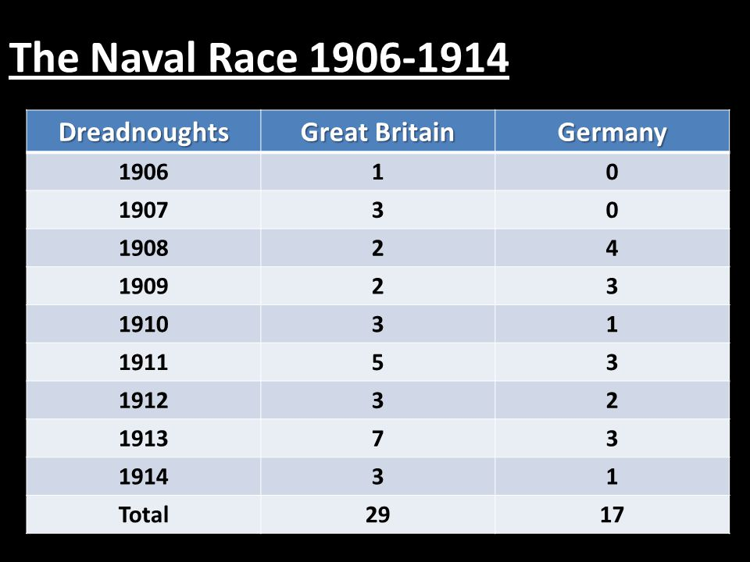  1)MAIN Causes of WW1  Militarism Building up your armed forces to show your strength  Alliances Agreements between countries to fight for one another  Imperialism The desire to build an empire  Nationalism Belief in the superiority of a nation | 3) The Battle of The Somme  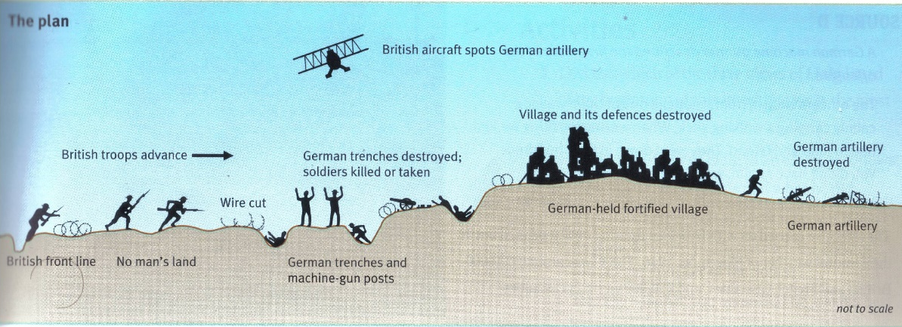  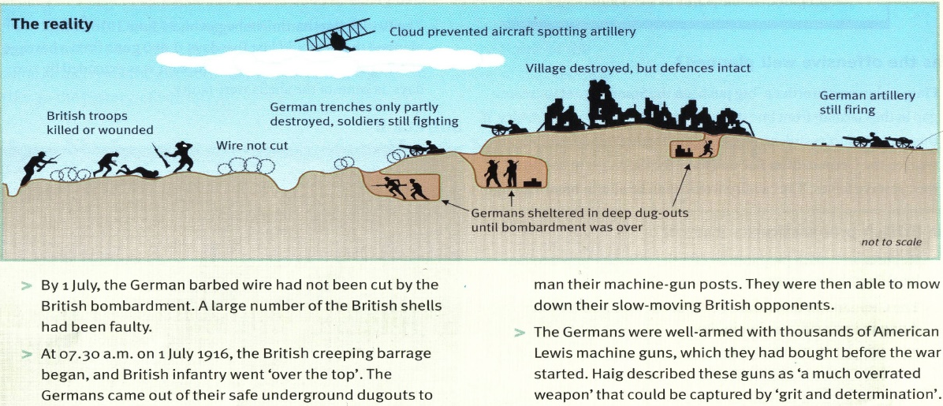  4) Life in the trenches: key terms/ideas  Stalemate No-man’s land Trench foot Trench fever Poor food and sanitation  Poison gas Mortars Artillery bombardment “Over the top” Dug-outs  Shell shock Attritional warfare Tanks Parados & Parapet Sandbag Barbed wire  Machine guns Rifles Rats  November 11th 1918. Armistice Day  July- Nov 1917  Third Battle of Ypres (Passchendale)  April-May 1915  Second Battle of Ypres  June 28th 1919. Treaty of Versailles

