Art Quiz
1 | What is the name for a quick drawing? |  | 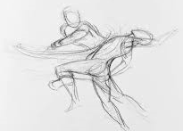
 | a | A skit
 | b | A scratch
 | c | A screech
 | d | A sketch
2 | Colour, line, shape, form, space, tonal value, pattern & texture are all known as what? |  | 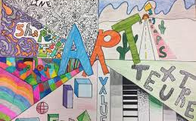
 | a | Shorter words about art
 | b | The elements of art
 | c | Names of different medias
 | d | Styles of painting
3 | If you were asked to do a ‘blind contour drawing’, what wouldn’t you do? |  | 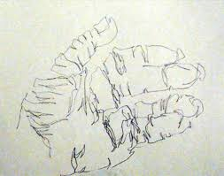
 | a | Use charcoal
 | b | Open your eyes
 | c | Look at the paper
 | d | Look at the finished drawing
4 | Why is it important to experiment with different materials when creating art? |  | 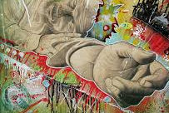
 | a | Because you never know what might happen
 | b | Because the results might be really interesting
 | c | Because the best ideas sometimes happen by accident
 | d | All of the above
5 | What is the name for a piece of artwork which uses more than one medium? |  | 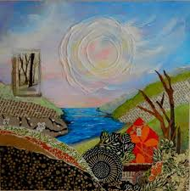
 | a | Muddled media
 | b | Mixed media
 | c | Messed media
 | d | Mashed media
6 | Which of theses options best describes a good sketchbook page? |  | 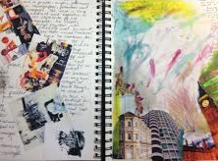
 | a | Crisp, clean & free of marks
 | b | An insight into an artist’s ideas and intentions, as well as the influence of other artists
 | c | A photocopy of someone else’s work
 | d | A long list of things the artist might do one day
7 | A series of sketches of the same thing might be what? |  | 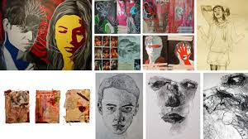
 | a | Identical in every way
 | b | Done only on a certain day
 | c | Done from different perspectives or in a different media
 | d | Done to fill some time in during a lesson
8 | What does the term ‘monochrome’ mean? |  | 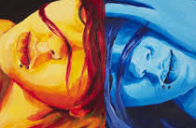
 | a | Created in silence
 | b | Being mainly in one colour
 | c | Abstract work using more than one medium
 | d | Paintings of metal objects
9 | Which word describes the arrangement, layout or structure of a piece of artwork? |  | 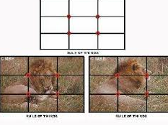
 | a | Composite
 | b | Composer
 | c | Composting
 | d | composition
10 | If an artist is struggling to see ways to improve their art work, what might they do? |  | 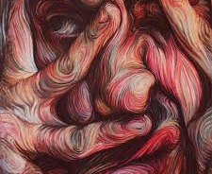
 | a | Ask a friend or fellow artist for advice and opinions
 | b | Start again
 | c | Give the art away
 | d | Keep going and see what happens – because even mistakes are useful
11 | What can be warm, cool, complementary, contrasting, primary, secondary and tertiary? |  | 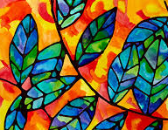
 | a | Colours
 | b | Pencils
 | c | Artists rooms
 | d | Schools
12 | Why is it important to make changes & improvements to a piece of artwork? |  | 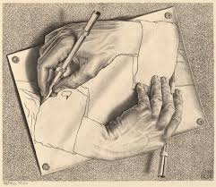
 | a | Because everyone else does it
 | b | Because a few changes could mean a massive improvement
 | c | Because the art teacher says so
 | d | To take up more time in lessons
13 | Why is shading important in a drawing? |  | 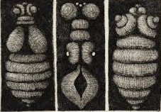
 | a | To create an impression of form
 | b | To keep a drawing out of the sun
 | c | For fun
 | d | To add detail
14 | What are hatching & cross hatching? |  | 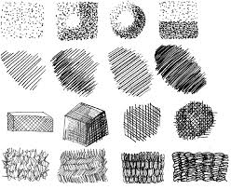
 | a | Ways of drawing into wood
 | b | Technical diagrams
 | c | Drawings of baby chicks
 | d | Groups of lines in different directions to create shading and tone
15 | It is important for artists to see the space between and around the objects they draw. What do we call these spaces? |  | 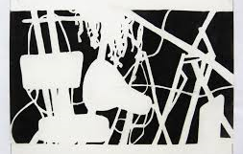
 | a | Positive space
 | b | Negative space
 | c | Neutral space
 | d | Blank space

