Mandala patterns
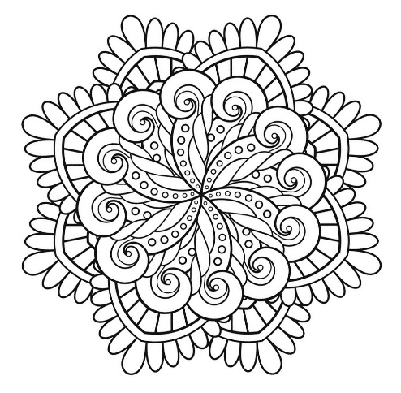

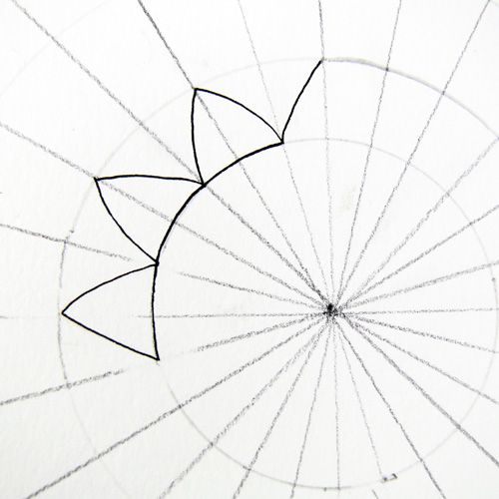

m Finish the image below by drawing a mirror image of the half you see.
(if you are left handed, turn the paper upside down)
& have a go at adding some colour afterwards!

Challenge …. Can you design your own mandala using these circles, dots & lines as your guide….

