Welcome to your new school Tiverton High School!

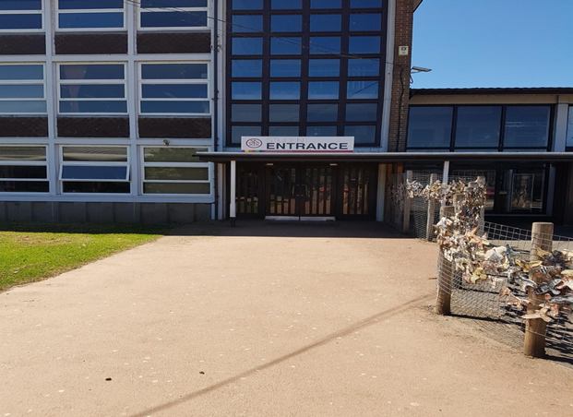 | This is the student entrance where you must enter and exit the school. The door next to this is the entrance for staff and visitors. Please do not use this entrance into reception.
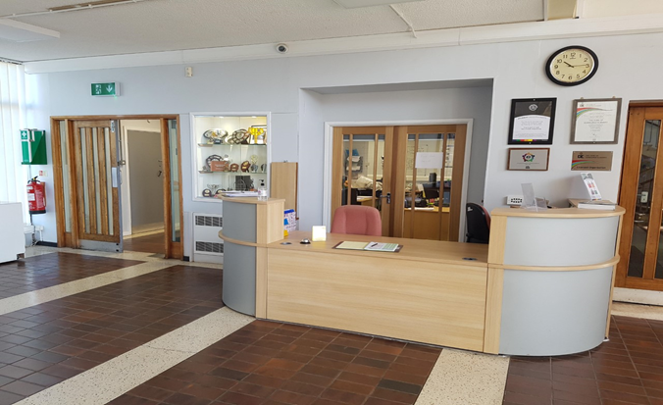 | This is the reception area, where students in Year 7 and 8 complete a day on reception. You can not wait in reception as you will need to be in lessons but if you have any letters/ forms to hand in, you can do that here.
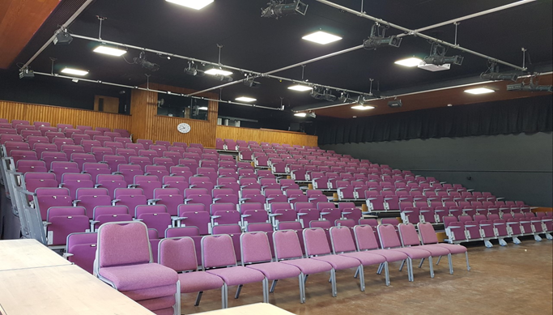 | Twice a week you will have main assembly in the hall. You have to line up with your tutor group in silence and sit down in silence. You may listen to a short talk and notices or join in with activities. The hall is also used for other events in the school year, e.g. Options Evening. On your first day, you will come here to listen to the head teacher’s welcome talk.
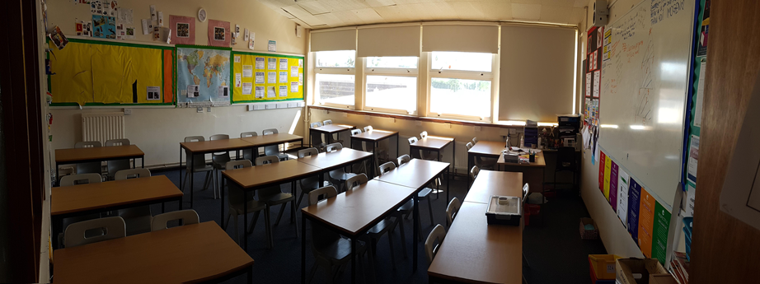 | You will then go to your tutor room to spend some time with your tutor teacher and the rest of your class.  Here you will be given your school timetable and go through the school rules and other useful information.
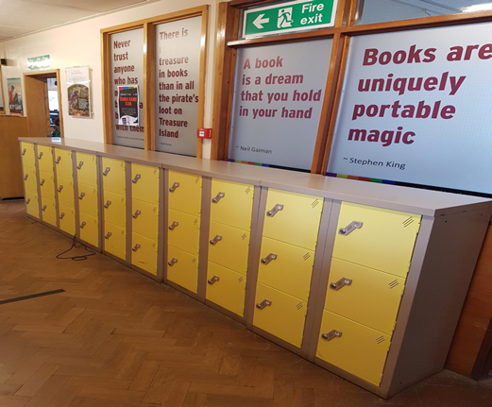 | There are lockers outside of the library. This will save you from carrying all of your books around. Just take out the ones you need before registration and at lunch. You can keep your coat in them too.
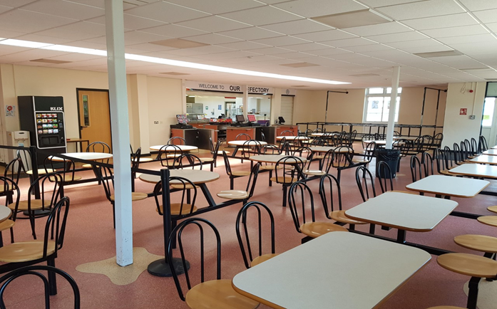 | The refectory is where a lot of students eat their break or lunch. No food can be taken out of here. If you are having refectory food you must line up outside but if you have packed lunch you can got to the sports hall and just sit down.
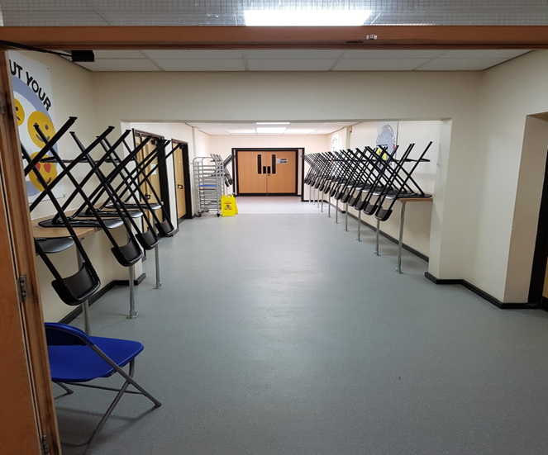 | The calm zone, in the refectory, can be used at break and lunchtimes to eat your lunch or chat with friends. You will be given a sticker to put on your ID card. A teaching assistant will be there to help you and support you if needed at lunchtimes.
Other useful places to know about
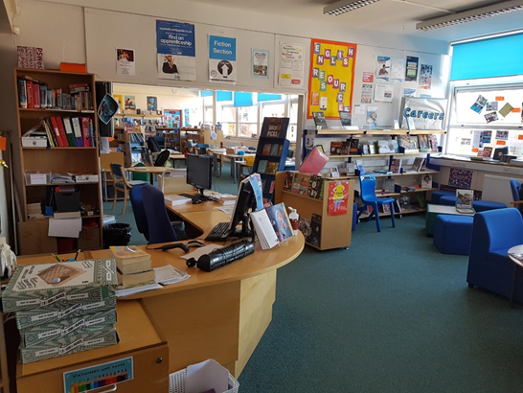 | The library can be used most lunchtimes to print out work or to do homework. You can talk to the librarian about choice of books, make suggestions and also help in the library. You may also have some lessons in there.
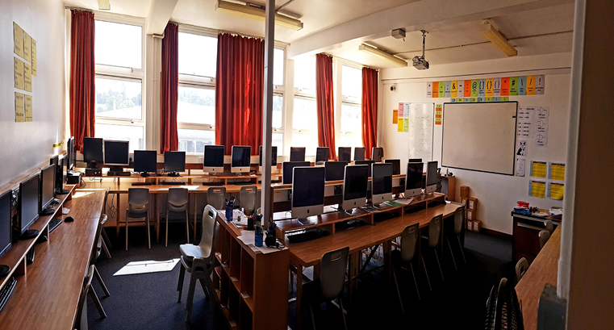 | This is one of the computer room which can be used at lunchtimes for clubs such as Raspberry PI and ???. The ICT helpdesk technicians can be found in a room just off this one.
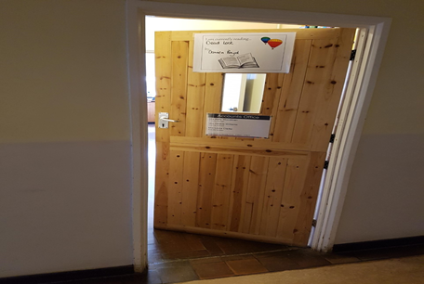 | The accounts office is near reception on the Science corridor. If you need to pay for anything, e.g. trips, then you should bring your money here.
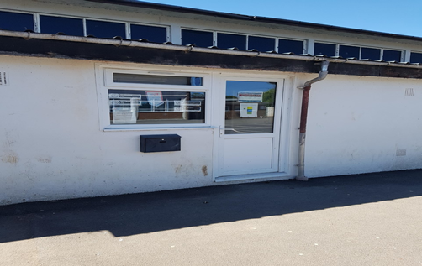 | The PE office is in the quad. You will often find the PE staff here. Many lunchtime and after school clubs are based here e.g. basketball.
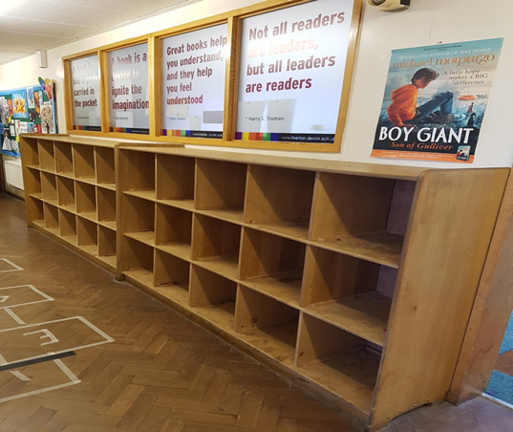 | In some lessons, e.g. library, you will have to leave your school bag outside. If you have anything valuable you must take this with you. The lockers outside the library are open ones.
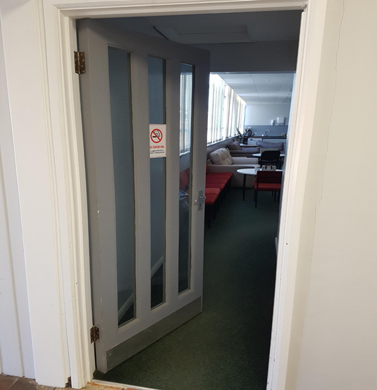 | The staffroom is near the main hall behind reception. The doors before the staff room will be shut and are for staff only. If you need to speak to a member of staff then wait by reception and ask them politely to see if the teacher you need is in the staffroom.
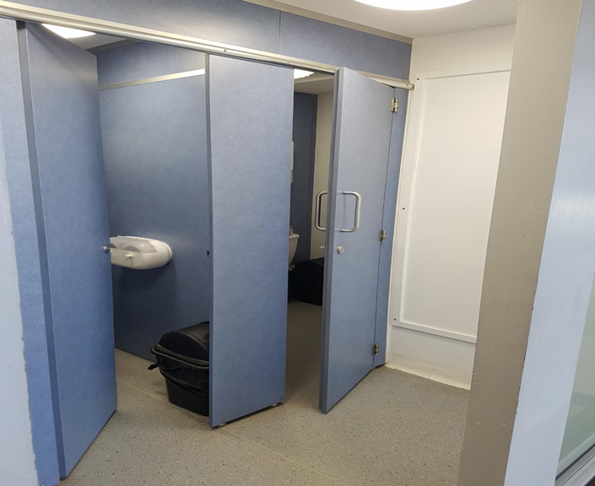 | Student toilets can be found around the school, these are unisex toilets by the student entrance. You should only use them at break or lunch - you will need to ask if you need to use them in lesson time and you will be issued with a card to take with you.
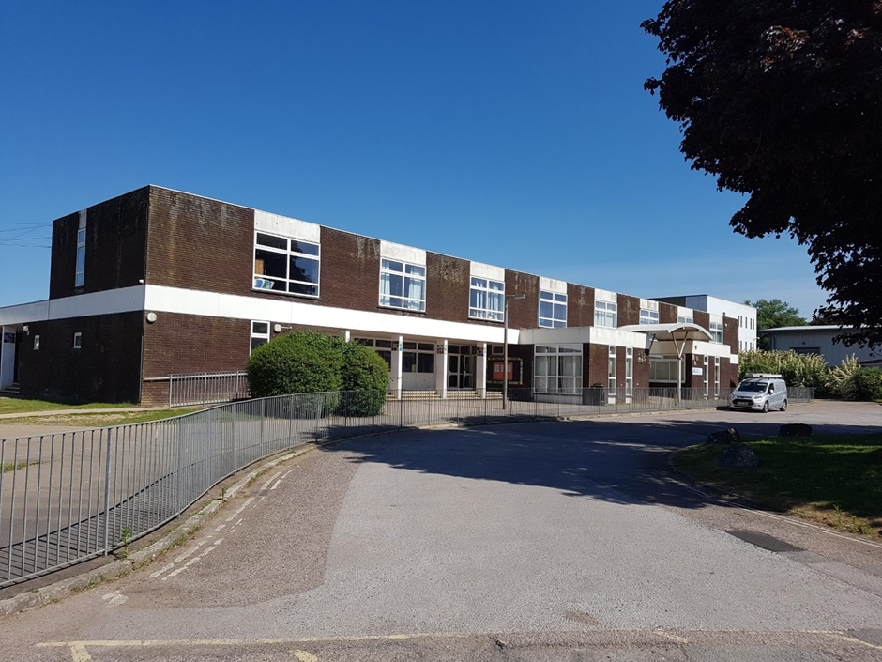 | The Support Centre is where you will find the SEND team. You may come here to have an intervention or come to join in with the Sanctuary Club at break or lunchtimes. You may have some questions and would like to come and have a chat, you are very welcome but you can also chat to your tutor and your Head of House.
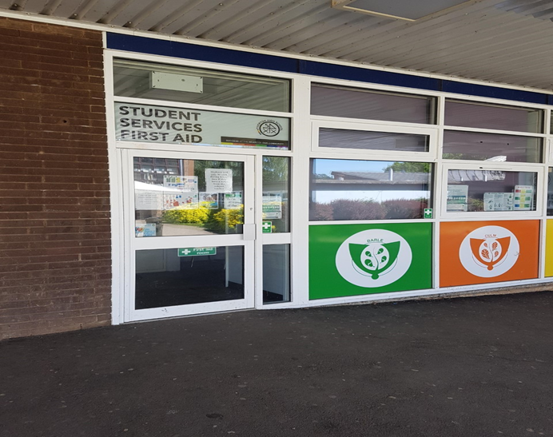 | If you are feeling unwell or need to go to First Aid you will find them across the way from the student entrance at the front of the school.
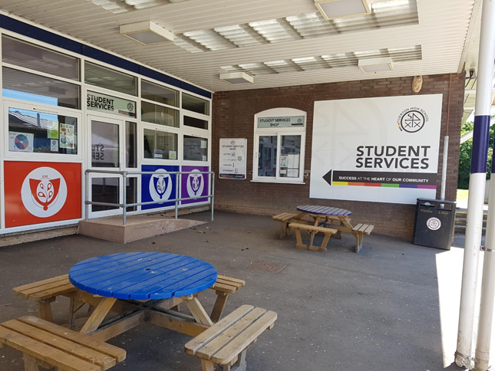 | Student services is a one stop shop for uniform, attendance student support workers and also the Heads of House. You will find them all in one are by the coloured benches. Can you guess which house belongs to which colour? How many colours and houses are there?

