- 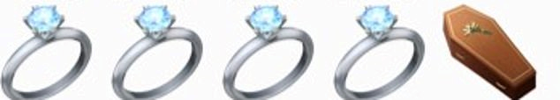
- 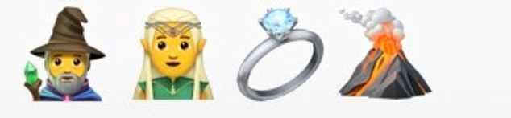
- What’s the orange bit in the middle of the egg called?
- What’s the collective name for trees that keep their leaves all year round
- What football team is currently at the top of the Premier League?
- What is the 10th letter of the alphabet?
- Who is the nation’s PE teacher?
- How many zeros are there in one thousand?
- Who wrote the Harry Potter books?
- Who is the Prime Minister of Britain?
- What is closer to earth, the moon or the sun?
- Which travels faster, light or sound?
- Who is the fastest 100m runner in the world ever?
- What’s the name of Anna and Elsa’s kingdom in Frozen?
- How many wives did Henry VIII have?
- What’s the name of the cowboy in Toy Story?
- Who wrote the Gruffalo, Room on the Broom and Tiddler?
- What type of fish is Nemo?
- What is the chemical formula for water?
- How many planets are in our solar system?
- Who was behind the Gunpowder Plot on the Houses of Parliament in 1605 - remembered every year on Bonfire Night?
- How many players are in a football team?

