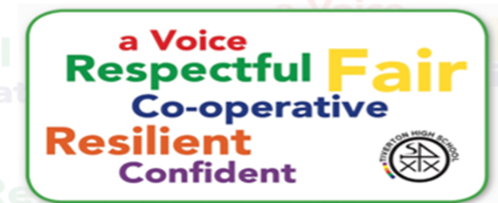



My best piece of writing

**Please write a poem, story or real-life interesting experience that you have had**

|  |
| --- |
|  |
|  |
|  |
|  |
|  |
|  |
|  |
|  |
|  |
|  |
|  |
|  |
|  |
|  |
|  |
|  |
|  |
|  |
|  |
|  |
|  |
|  |

** Tiverton High School** 

**Tell us about the best book that you have read and why you enjoyed it.**

**Tell us about any books that you have read during the last year.**



|  |
| --- |
|  |
|  |
|  |
|  |
|  |
|  |
|  |
|  |
|  |
|  |
|  |
|  |
|  |
|  |
|  |
|  |
|  |
|  |
|  |
|  |
|  |
|  |