About the School

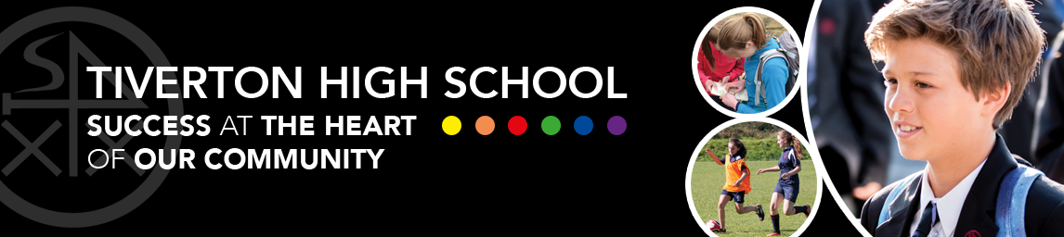

When you visit our school you will see these words everywhere. They reflect our school’s ethos. These powerful messages emerged from a consultation with our stakeholders.

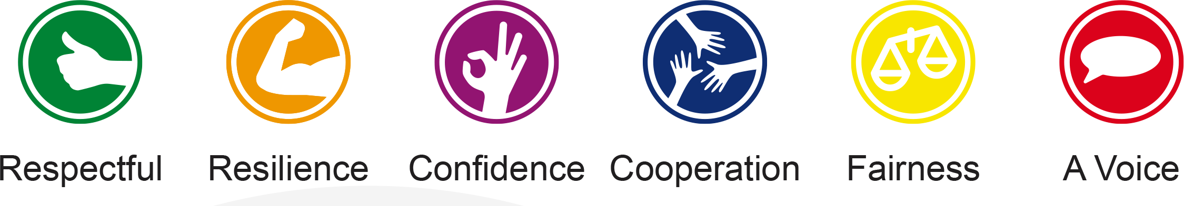

Tiverton High School is truly at the heart of our community. The school is a mixed Co-operative Foundation Trust School, being part of the Tiverton Co-operative Learning Partnership with Petroc College, Tiverton Community Arts Theatre (TCAT), 11 primary schools, sports clubs and establishments and a major textiles company in the town. It also works in partnership with other cooperative schools in the area.
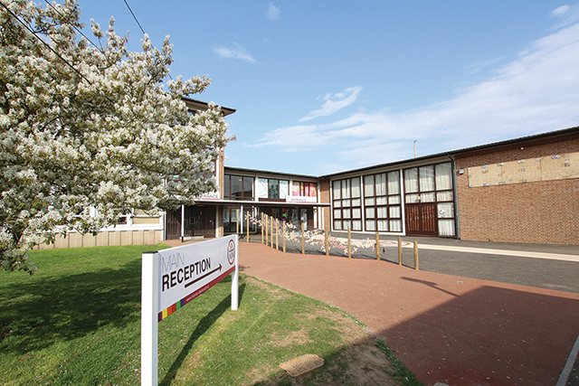 | Tiverton High School  is truly at the heart  of our community.

Our school’s mission is based on the enthusiasm and belief in student potential. An inspired mind is a flourishing individual and that is what they aim form!
Here is what some of our students have said about Tiverton High School…
- “gives pupils the confidence and self-esteem throughout their school life.”
- “is a secure, supportive environment where every student is welcome and accepted, regardless of race, religion or any other factor.”
- “there is something for everybody at THS.”
- “encourages and develops our capabilities.”
- “helps each pupil succeed in life by providing the best teaching, education and
encouragement.”
- “allows students to express their individuality.”
- “gives students a voice so they can make a stand and make a difference.”

“Gives pupils  the confidence  and self-esteem throughout their  school life.” | 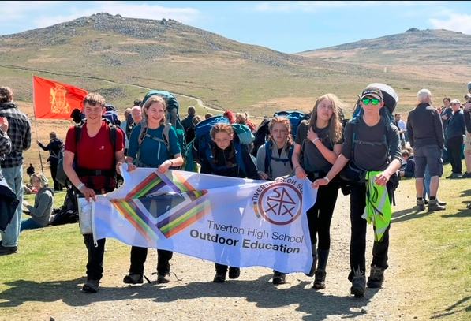
This is some of what Ofsted said about our school:
- There are high expectations of teachers and students. Leaders and teachers have developed their knowledge and improved the skills necessary to raise the quality of teaching which is now good.
- Most students have developed positive attitudes to learning. They want to achieve and therefore they work hard. The drive to raise the aspirations of all students is now ensuring that more strive to achieve their best.
- The proportion of disabled students and those who have special educational needs is around double the national average.
- The school has specially resourced provision for disabled students and those with special educational needs in the form of a specialist communication and interaction resource base, known as the CAIRB. This provision is commissioned by the Local Authority and is currently full.
- A greater proportion than average of Year 7 students are eligible for catch-up funding. This funding is to support students who did not achieve the nationally expected levels in English and mathematics at the end of primary school.
- The school meets the current government floor standards, which set the minimum expectations for students’ attainment and progress by the end of Year 11.

Ofsted 2019
“You lead a highly inclusive school which benefits pupils and the local community.”
“There is a strong sense of common purpose in the school. Your concern for
individuals is a striking feature of your leadership, which you summed up with the statement, ‘We stopped working with data; we started working with pupils.’”
“Governors, leaders, teachers and other staff are committed to the school and
are ambitious for its future.”

“Most students have developed positive attitudes to learning.”
Ofsted

The Federation
Tiverton High School is part of ‘The federation of Tiverton Schools, comprising of Tiverton High school, Heathcoat Primary school and Rackenford primary school.
This federation was established in 2016 and the substantive Head of the High School is also the Executive Head of the Federation supported by the leaders at THS and a Head of school at each of the primaries.
As a federation we work in partnership to provide the best experiences and opportunities for our young people.
Some colleagues work across the three schools, for example our site team and some office staff. Pre covid children from HPS would come to THS for science and ICT lessons and we are returning to this model during this academic year. In addition to this we benefit by running a nuture group of new year 7 students at THS taught by a primary trained colleague.
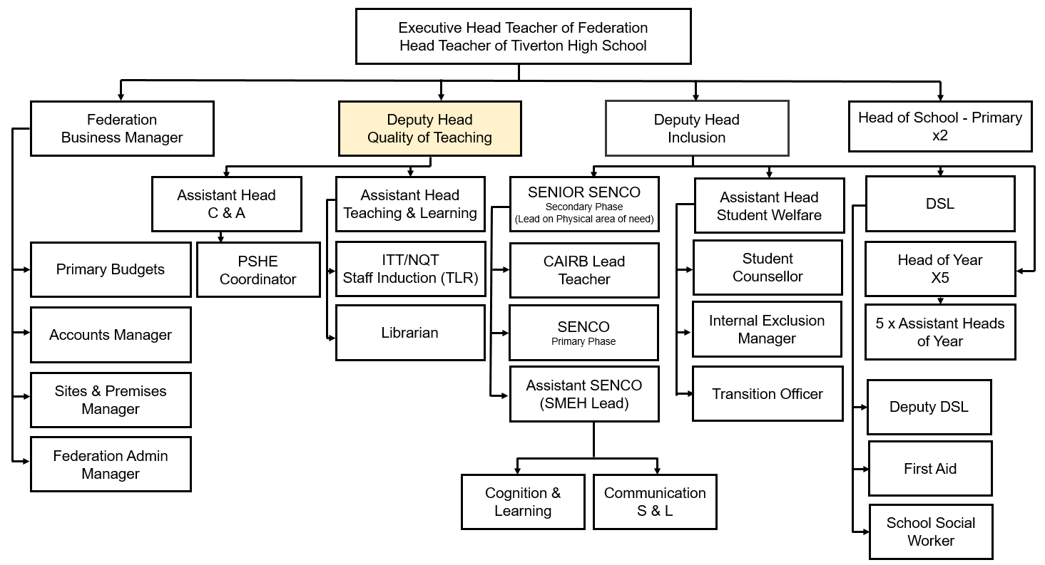

The Governing Body

Following a formal agreement to federate three local schools in November 2016 we are a very newly constituted governing body made up of representatives from parents, staff, foundation, local authority and co-opted governors most of whom previously served on the governing bodies of the three federated schools of Tiverton High School, Heathcoat Primary School and Rackenford Church of England Primary School.
We work with our schools and leaders to ensure a high quality, inclusive education which enables all students to maximise their potential and make greater progress than expected.
To achieve this we:
- support and challenge leaders
- have knowledge of the student experience
- have a comprehensive understanding of how the schools work
- have the benefits of the students at the heart of all our decisions
- strive to engage with parents
- ensure governors are well trained

The Full Governing Body (FGB) has the following Sub-groups for both primary and secondary phase which are chaired by governors and report to FGB:
- Resources and Personnel
- Learning Progress and Welfare
- Ethos

The FGB has First and Second Committees to deal with Disciplinary/Exclusions/Appeals
In addition the FGB aims to set up any further local groups needed to focus on specific local issues relating to each of the three federated schools. These groups will be made up of a mix of governors and other members of the community with the relevant skills and knowledge applicable to each local group.
“Helps each pupil  succeed in life by providing the best teaching, education and  encouragement.” | 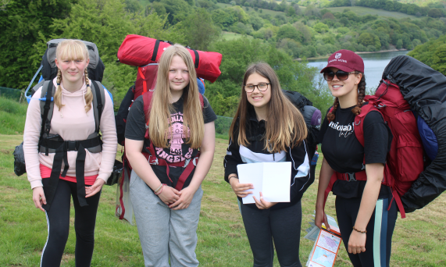

Introduction to local area
Tiverton is an ancient market town set in the hills between Dartmoor and Exmoor, on the banks of the Rivers Exe and Lowman.

Its occupation dates back to the Stone Age. It is the main commercial and administrative centre of the Mid Devon district with a population in excess of twenty thousand. It has a thriving town centre with many independent stores as well as some of the more well-known chains. There is a Norman castle and a museum.

It is 15 miles from the thriving city of Exeter and 7 miles off the M5 motorway.

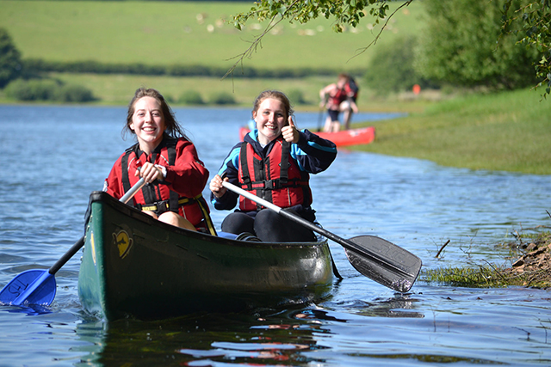 | “There is something for everybody at THS.”

Curriculum and Learning

Our curriculum is based upon the National Curriculum programmes of study at Key Stages 3 and 4 and is timetabled using a 50 period two week timetable. Our curriculum has been developed to meet the requirements of current national guidelines and our commitment to the provision of a wide range of subjects, including breadth in our arts subjects which is one of our school strengths.

All students at KS4 take at least one subject which reflects the English Baccalaureate range of subjects. All students follow the statutory PSHE curriculum through a series of lessons with their Tutor and specialist external providers.

In Years 8 students study the following subjects: English, Mathematics, Science, Computing, Design Technology, Food Technology, French, German, History, Geography, Religious Education, Art, Music, Drama, Physical Education, as well as a PSHE programme which delivers personal, social, health, citizenship and careers education. We are an NCS Champion School.

From Year 9 students study the core curriculum of English, Mathematics, Science and PE alongside a set of subjects that they have opted for. At the end of Year 9 these option subjects are further refined to a set of qualifications to be taken at the end of Year 11. Students have a wide range of GCSE and vocational subjects to choose from that includes arts, Performance, DT, ICT, PE, humanities subjects and Health and Social Care. The study of a modern foreign language at GCSE in not compulsory, but the study of an ‘Ebacc’ subject is. Most students will go to gain 9 GCSEs or equivalent.

Students are grouped in a variety of ways according to the needs of the subject. This includes fine setting and mixed ability teaching as appropriate.
Support for students with Special Educational Needs, and those for whom English is an additional language, is provided in class and through interventions with literacy support staff. Support for EAL students is provided through literacy support staff and classroom staff.

The curriculum is designed and delivered on the principle of students ‘mastering Key constructs’ within each subject area. Formal assessments of learning are conducted according to our Assessment, Recording and Reporting schedule and targets are available to view by parents and students via our online school information platform ‘Go4Schools’.

Home learning is delivered for all year groups across all subjects using ‘Google Classroom’.

Reading

Reading is a fundamental skill and a priority for all at THS. Being able to read competently and confidently means students will be able to access the complete secondary curriculum. The launch of the reading programme in September 2022, to include tutor reading and D.E.A.R, provides students with the opportunity to practise reading skills and develop their comprehension of texts. The aim at THS is for all students to be able to read fluently and accurately and so our targeted reading intervention programme, involving the teaching of phonics, supports students who are not reading at their chronological age. Here at THS, it is our collective responsibility to frequently provide students with opportunities to develop their vocabulary, enhance their reading skills through reading practice and foster life-long habits of reading for pleasure.
There are three aspects of 'Reading at THS':
THS Tutorial Reading Programme:
THS Tutorial Reading Programme dedicates one weekly tutor period for the tutor group to read as a shared experience. The students are read a book each term by their tutor and students are provided with their own copies of the book so they can follow the text and discuss together. Across the five years, students will read 14 enriching books with their tutor group. The ‘THS Top Reads’ is a collection of texts which hold significant value for different reasons: the style of writing, the messages they give or the issues explored. The books have been chosen as texts that will:
- provoke thought
- bring depth, colour and culture to students’ lives
- show the world from many perspectives
- bring a greater understanding of the way we and the world work
- develop their cultural capital
- be a pleasure to read
D.E.A.R “Drop Everything and Read”:
Time is set aside in the curriculum timetable for both students and their teachers to read their personal book choices for 20 minutes each week on a rolling programme. Books are a part of the THS equipment list and each student is encouraged to select their own choice to suit their interest and ability level.
Targeted Reading Intervention Programme
Students at a reading age of ten years or below receive targeted and personal reading intervention programmes involving the teaching of phonics and spelling in order to improve reading skills to their chronological age.
“Allows students to express their individuality.” | 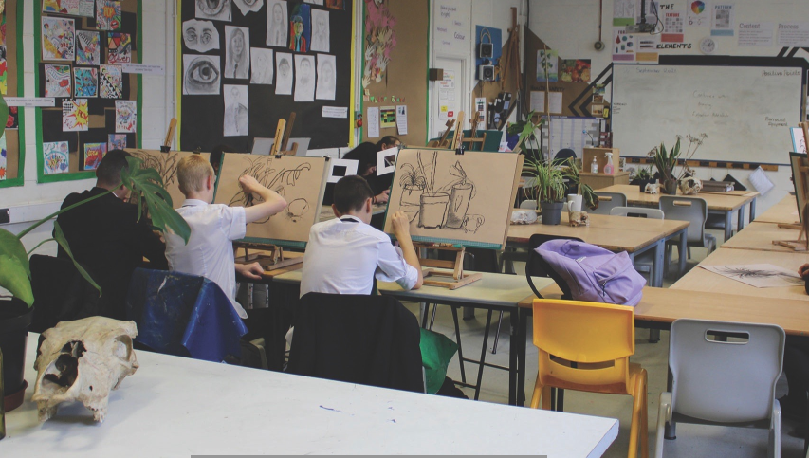

The THS Community
THS is a mixed Cooperative Foundation Trust School and prides itself on being truly at the heart of our community. It is a founding member of the Tiverton Cooperative Learning Partnership, (TCLP) alongside 11 local primary schools and Petroc College, and partners from the arts and business community. A key member of the partnership is Tiverton Community Arts Theatre (TCAT), which successfully delivers a vibrant programme of professional drama, comedy, and music in the theatre at the school. Community performing arts organisations are well represented and THS is home to the Willow Tree Centre of Performing Arts, The Tiverton Concert Band and East Devon Choral Society. We are also proud to make our facilities available to many local sporting groups including Moors Football and Exe Valley Gymnastics. During the evenings and at weekends you will find the THS campus alive with the host of activities on offer to community members of all ages but particularly our young people.

Growth in the area

The current population of Mid Devon is approximately 64,000 with just over 20,000 of these living in and around Tiverton. Much investment in infrastructure and housing has taken place in recent years with up to a further 3,000 homes scheduled to be built at the Eastern edge of the town in the near future.

THS is destined to grow significantly as a result of this development and plans are in place to build a new school, with capacity for up to 1800 students, on land adjacent to our present site. This exciting project will be delivered in partnership with Tiverton Community Arts Theatre (TCAT) which has plans in place to build a new £10 million theatre and arts centre.

Extra-curricular
We would encourage you to read the weekly school bulletins and view our website to find out more about all the events and activities that go on in our school every week including sporting achievements, participating in Ten Tors, music, Interact Club (fundraising in partnership with Rotary) as well as a range of visiting speakers and external visits and subject trips.

The school offers clubs at lunch time and before and after school in areas such as sport, performing arts and general interest (offering a variety of interests ranging from surf club to creative cooking and gaming).

We take pride in our annual musical production - our last one was Grease in December 2019 which was performed for 5 nights to a sell-out audience.

In the last few years we have produced Cats, Oliver, Annie, Joseph and his Amazing Technicolor Dreamcoat, We Will Rock You and Little Shop of Horrors.

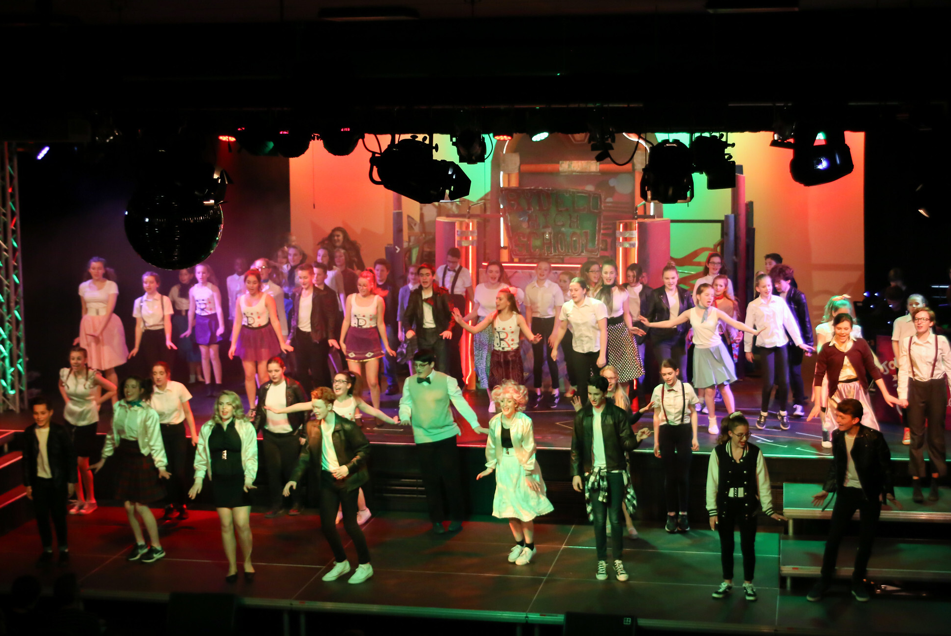 | “Gives students a  voice so they can  make a stand and  make a difference.”

Activities week is a new initiative which was a huge success last year. Students are offered events all week ranging from trips abroad to local low cost or free daily activities with something to suit all tastes and budgets.

Pastoral System
The Academic year 2020/21 saw a significant change in our pastoral system.
The school now has five Heads of Year, and tutor groups include students only from within their own school year. This is called a ‘horizontal’ system, and is the way many secondary schools currently operate.
Back in 2009 the school moved to a vertical system, where tutor groups included students from across all year groups, and there were six Heads of House. For some time now we’ve wanted to move away from this system.
This change has been necessary to pursue our aim of becoming an outstanding school. It will help us provide a better level of support, and enable both students and staff to flourish.
House and tutor group pride is fostered through healthy competition.
Our pastoral team includes Assistant Heads of Year (non-teaching), Early Help Coordinator, School Counsellor, the attendance team and the school nurses to provide the very best in pastoral care for all students and are the link between the school and home.

School dog – Bramble
We introduced Bramble into the Federation as the school dog to support learning and emotional development in the school. This has been a hugely positive step and one we wish to embrace further in the future.
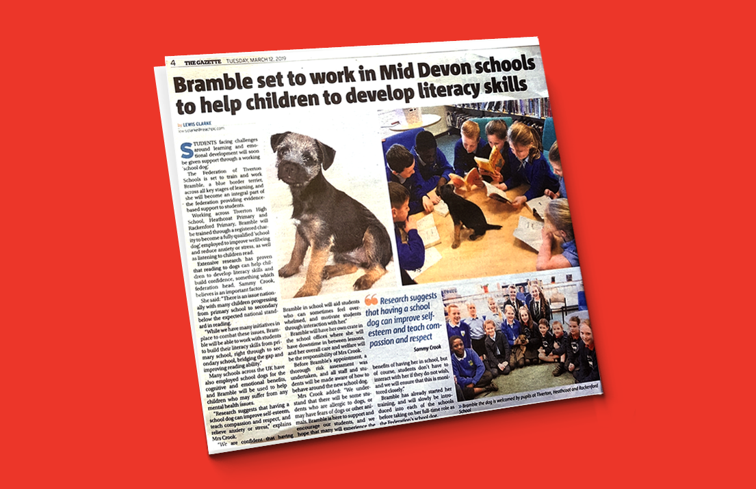

Staff and Student Mental Health and Wellbeing
At THS, we aim to promote positive mental health for every member of our staff and student body. We are a Well School which aims to help improve education outcomes by placing wellbeing at its very heart to support school staff, senior leaders and young people. A Well School places just as much emphasis on wellbeing as it does on academic performance. It understands that children and young people are more effective learners when they are happy and well and that they must take care of their staff and their students wellbeing to create a culture that allows everyone to reach their potential.

In July 2022 we were awarded the Schools Mental Health Award. The Mental Health Award for Schools provides a framework for schools to evidence policies and initiatives that work towards improving emotional health and wellbeing for both staff and pupils.

Supporting staff mental health and well-being is important to us as a school. It is vital that those responsible for teaching and inspiring this generation of children are well enough to keep showing up for their students. We therefore invest in support for staff and have a range of initiatives from planned wellbeing activities, to secret staff buddies to Friday afternoon tea club. We have been chosen as one of 25 schools to take part in The Youth Sport Trust Big Give Project which supports schools to deliver an intervention to improve staff well-being. We have also signed up for the Education Staff Wellbeing Charter which is a declaration of support for, and set of commitments to, the wellbeing and mental health of everyone working in education.

We have recently trained students to become wellbeing ambassadors and will continue to train more students over the coming year. We know that young people can sometimes find it hard to talk to adults about their worries or any difficulties they are facing. Some young people may not have an adult in their life they can trust, and others may feel they’ll be judged or that an adult won’t take their problems seriously. Having other young people who can offer them support or point them to where they can gain specific support is vital to these individuals to protect their mental health and promote wellbeing. The Wellbeing Ambassadors Programme empowers young people to lead wellbeing initiatives to provide peer to peer support such as drop-in sessions, one to one peer coaching, campaigns to increase awareness of mental health and reduce stigma around discussing mental health problems. There are many benefits for the students who are trained as ambassadors as well as the peers who are receiving support.

On-site Social Worker
At Tiverton High School we are very pleased to be working alongside The Social Worker in Schools Project and have been chosen to have a resident social worker onsite until August 2023. Emma Rose is the allocated social worker based at Tiverton High School full time. Alongside having a caseload of families that she works with she is also on site to support staff, parents/carers and pupils who are experiencing difficulties. Emma’s remit means families do not need to be open to children’s social care for her to offer support and she can be involved in appropriate early help meetings as well as giving one off advise to families and pupils who maybe struggling at a particular time.
Thank you for taking the time to learn more about our school.

